Three Lakes Association Summer Internship Program 2022:

Distribution of Diporeia and Mussels in Torch Lake Sediment
Each summer Three Lakes Association has a project to study some aspect of our watershed in order to make sure we are protecting water quality, our mission. TLA interns have studied the shoreline, cladophora, lake bottoms, water and phosphorus flows, E.coli, beach contamination, glacial relicts, groundwater, water quality depth profiles, and many other topics. This year TLA will look at organisms living at the bottom of our deepest lake, Torch Lake, as part of an ongoing project to find out if our watershed is being altered by activities of man.
TLA has a record of monitoring water quality in our lakes extending back 45 years and has developed a computer model of the keystone nutrient, phosphorus, in these lakes. Phosphorus is necessary for the life of all animals and plants but too much of it in our lakes can lead to uncontrolled plankton and algae growth. In this respect Torch Lake is one of the cleanest Lakes in the nation with a phosphorus level of 2.6 parts per billion. The lakes and streams feeding into Torch Lake are also pristine as there is little industry in our area.
However, sometimes it is difficult to determine what to monitor in order to understand our complex ecosystem. So, this year we will be exploring the oldest structures in our area, the deep bottom sediment in Torch Lake which has been almost undisturbed since the last ice age, over 10,000 years ago, and the creatures that live there (we hope). In 2007 TLA Interns collected samples from the deep lake sediment to determine if a certain crustacean, diporeia, still lives there. This particular creature was first introduced to our lakes when they were still connected to the oceans literally millions of years ago and have found the environment welcoming ever since. They are also easy to see and count, and TLA has several previous studies with which to compare them going back to the 1950s. So, we are going to use small sampling dredges to take a few centimeters of sediment from the bottom and examine it for the existence of diporeia, a small crustacean which besides possum shrimp are virtually the only creatures that live there.
>40 cm< >3 cm <
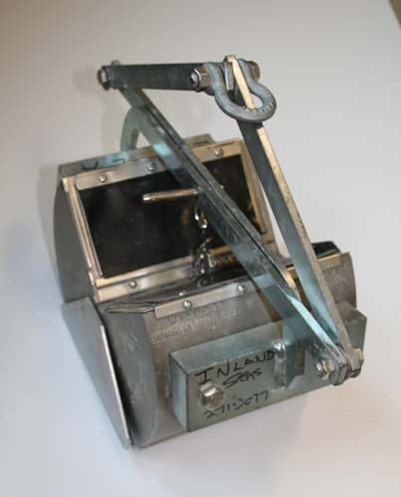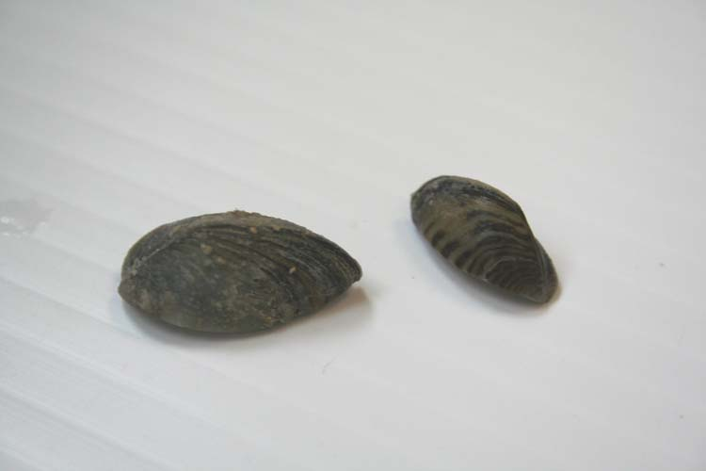
PONAR Dredge Zebra mussels

Part of science is exploratory, and this is an opportunity to “go where no one else has gone.” and it is literally in our own back yard. We don’t have to launch satellites or visit Antarctica to do it. We also have no clear idea how they fit in to our own ecosystem, except that we can guess that they have a niche at the bottom of the fish food chain and are, probably, important. Maybe one of our students can figure this out.

>0.5 mm < >2 mm <
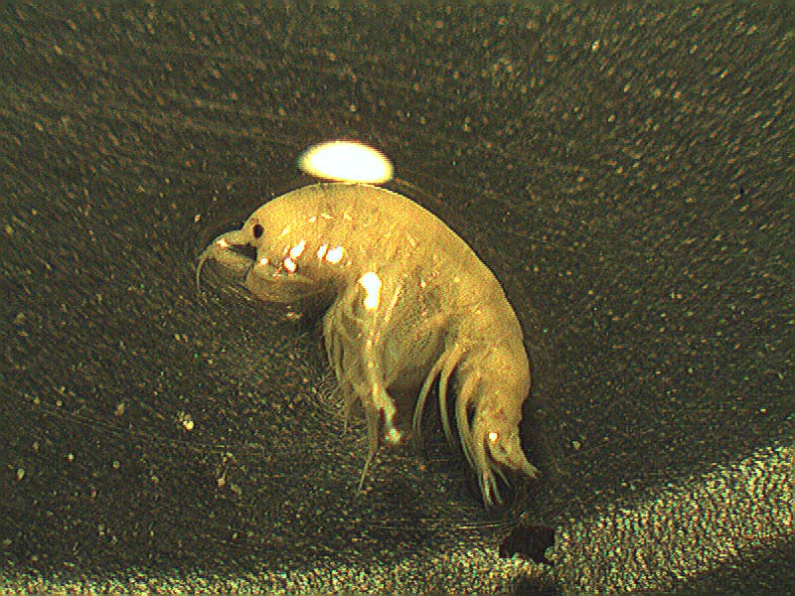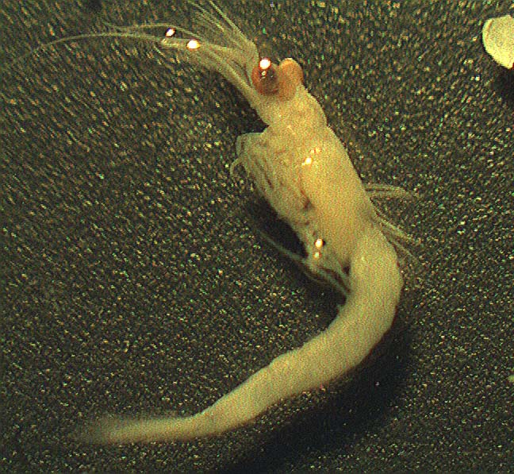
Diporeia possum shrimp

Also, we are going to dredge some shallower waters in Torch to find out how our newest invasive creatures are doing. Zebra mussels first entered our waters in the 1980s from ship ballast water from Europe, and they are all over our shallow lake regions today. They are a well-known threat that clog water inlets, crowd out native mussels, and can cut tender feet. However, zebra mussels only live in shallow water down to about 50 ft. Recently, another similar mussel, the quagga, has begun to replace zebras in the great lakes, which reproduces even faster than zebras and is comfortable living even at the bottom of our deepest lakes, where in Torch Lake diporeia have lived for millennia. We would like to have a base-line of this interaction should it occur, hence this project. When we last looked in 2007, there were no zebra or quagga mussels on the bottom. This project will be the first to see if quaggas have shown up or not and where they live. We will also sample some intermediate depths to see if they are in Torch Lake at all. We only found zebras mussels in similar TLA survey in 2007, no quaggas at all.
We expect that most of June and July will consist of data collection with August being reserved for compiling and writing. The deep sampling will be done with a small dredge that can be lowered from TLA volunteer boats, where we will carry out the preliminary counting of what we find. Then the interns will write a report on their findings to be part of the TLA archives. And finally, all of the interns will make a Power Point presentation to the TLA Board and their own school boards in August, September and October after the report has been completed.
We expect that our work will eventually make it into the scientific literature through our regular interactions with the Biology Departments at local colleges and the University of Michigan and Michigan State University where we interact regularly with other scientists. Members of our organization also use these reports to inform other Michigan lake organizations, like the Michigan Lakes and Streams Association to compare our lake with others in the state and nation, and we interact with the Michigan Department of Environment, Great Lakes, and Energy.

To contact us:
Please find our TLA Executive Director, Jeanie Williams at jwilliams.threelakes@gmail.com or 802-310-2285.
Or our Program Director Norton Bretz, at nlbretz@icloud.com or 231-631-8465.

