Torch Lake -- Flow Rates of Rivers and Tributaries:

2004 Summer Internship Report

By

Keenan Bailey and Anna Ash
Elk Rapids High School and
Three Lakes Association Interns
DEQ Grant Number 761P40021
December 30, 2004

Torch Lake -- Flow Rates of Rivers and Tributaries:
2004 Summer Internship Report
Abstract
In the spring of 2004, Dean Branson and Tim Hannert came to Elk Rapids High School’s A.P. Biology and Chemistry classes in search of summer interns for the Three Lakes Association. They presented their plan to create a water quality model for Torch Lake and eventually Lake Bellaire and Clam Lake. The Three Lakes Association was interested in having area youth involved in this project. After applying for the intern positions, we became involved with this project. In conjunction with Great Lakes Environmental Center, Three Lakes has now taken the first step in creating this model. In order to develop an accurate simulation, certain attributes of the lake needed to be measured. The majority of our internship was based on the collection of data that would be used to create the baseline for predicting the lake's future quality. We made flow measurements of the water going in and out of the lake, as well as phosphorous and turbidity measurements of the lake's tributaries. In the lake itself, we used the Hydrolab to measure dissolved oxygen, specific conductivity, temperature, and depth. We also collected water, sediment and plankton samples. All of the collected data will be loaded into the modeling software so that it will be able to predict the long-term impact of developing our area. Because of the Torch Lake area's incessant growth, this model is essential to help area decision makers maintain the pristine quality of the lake.

Introduction
Three Lakes Association and Great Lakes Environmental Center have begun to develop a predictive nutrient-based water quality model that can be utilized to create cost-effective water quality management decisions. This project will couple the importance of environmental protection with the economic growth of our community. The purpose of our internship was to aid in the measurement of the water flowing in and out of Torch Lake. This information is essential to the examination of the phosphorous levels that are entering and leaving the lake.
The phosphorus levels in Torch Lake will be modeled with a computer simulation using the current state of the lake systems and its impurities and flows, as a calibration. This requires not only a knowledge of the flows, impurities, and volumes, but also knowledge of the physical and chemical systems as well as the biological processes active in these lakes. The computer model uses the conditions of the lakes and the processes found to match the conditions of the system. The Three Lakes Association will use hydrodynamic and water quality models to predict nutrients. There are a number of water quality models built by different researchers and agencies for slightly different types of lake systems. One of these is CE-QUAL-W2, which was written by the US Army Corp of Engineers to study the eutrophication in interconnected lakes and reservoir systems. Another model is Lake2K which was developed by a well know researcher, Professor Steve Chapra, that is used for more isolated lake systems and emphasizes the physical processes more than the hydrodynamic flows. Neither model has been used extensively on clean systems such as Torch Lake, where the emphasis is on maintaining current water quality.
In Torch Lake’s ecosystem, phosphorus is the limiting elements for plant growth. Unnatural increases in phosphorous due to human interferences allows for increased growth of photosynthetic plants such as algae. This growth can disturb the homeostatic environment maintained by the lake. Knowing how much phosphorous is entering and leaving the lake is essential to the preservation of Torch Lake’s ecosystem.
In order to calibrate the water quality models, we established the water flows in and out of the lakes, and the impurity levels of these flows. The incoming flows are from tributaries, precipitation and groundwater. The outflows include Torch River and evaporation. Measuring the flow rates allows us to determine the hydraulic residence time of phosphorous in Torch Lake. The major tributaries that we measured which flow into Torch Lake are Clam River, Spencer, Meggison, Eastport, Wilkinson, and A-Ga Ming Creeks. Other factors that are sources of incoming water are precipitation, groundwater and underwater springs. The Torch River is the only tributary that flows out of Torch Lake.
Phosphorous levels in Torch River are less than the sum of the levels of phosphorous incoming from the tributaries. The phosphorus level in Torch Lake is found by multiplying the amount of phosphorus per kilogram by the number of kilograms of water in Torch (see Appendix A). This information can be used to calculate the time required to build the present phosphorus levels from the input flows. If this time is shorter than the average residency time the water spends in Torch, then we can infer that phosphorus is settling in the bottom sediments. Average residence time is calculated by dividing the outflow of water, in cubic feet per second (cfs), into the cubic feet volume of Torch Lake. The residence time turns out to be approximately 18 years (Stone).
To estimate the flow levels into Torch, we measured the flows in the tributaries directly and we calculated the flows of the tributaries and groundwater by estimating the drainage area and rainfall in a set period of time. The groundwater is difficult to measure directly but may be estimated by knowing the collection area and rainfall.
When determining the size of the Spencer Creek watershed, we discovered that the amount of drainage into the creek was significantly larger than we originally anticipated. Appendix B shows the boundaries of the Spencer Creek watershed extends into Kalkaska county, this increased area of water-distribution reveals the sphere of influence on Spencer Creek is considerably larger than we expected. (Appendices C through E show other watershed maps of local tributaries leading into Torch Lake)
We utilized the United States Geological Survey standardized method to measure the flow rates of the incoming and outgoing tributaries of Torch Lake. To measure the total flow of a tributary, we sectioned the river off into twenty segments of equal length across the river’s width. We placed the flow meter at twenty percent and eighty percent of the depth of each segment. The flow meter used was made by Global Water and was calibrated by them in June 2004. The probe was calibrated by comparing its measurements to a timed object in a uniformly flowing section of the river and by comparing the device to another calibrated flow probe owned by Great Lakes’ Environmental Center. The precision of the meter on the instrument is 0.01 mph, but the intrinsic accuracy is not as exact. These comparisons give an overall systematic accuracy adjustment factor of 1.7. Three Lakes Association is continuing to investigate this issue. In general the flows measured in a given day or week have the same systematic accuracy with an intrinsic uncertainty estimated to be about + 10%.
In general the flow in a channel is fastest near the center and top and slowest where the resistance is highest at the bottom and edges. We took the total flow to be an average of the 20% and 80% depths multiplied by the area of that panel and summed over all the panels in the river cross section.

Torch Lake Tributaries: 2004 Flow Rates

Tributary | Culvert Length (ft) | Time for a floating object to travel through culvert (seconds) 7-22-04* | Cross-sectional area (sq. ft.) | Calculated Flow (cfs)
Spencer Creek  East Culvert  West Culvert | 28.3 | 28  21.3 | 4.9  5.4 | 12.14  4.96  7.18
Meggison Creek | 69 | 17 | 0.111 | 0.45
Eastport Creek | 65 | 19.5 | 0.05 | 0.17
Wilkenson Creek | 48.3 | 780 | 10.6 | 0.66
A-Ga-Ming Creek  Two culverts | 63 | 18 | 0.76 | 2.66

* 7-22-04 was two days after a significant rainstorm, i.e. flow data represents part of a storm event.
The rainfall last year was thirty-one inches, and we can now use this rainfall and evaporation rate to estimate the tributary and groundwater flow by applying it to the drainage basin, not the lake area (Michigan Economic Corporation.) Eventually this water enters Torch, either quickly by tributaries or slowly by groundwater. Over several years the average rainfall should equal the average inflow from the tributaries and groundwater.
We used the Hydrolab Quanta water quality measurement device made by Hach to determine basic lake properties such as dissolved oxygen, temperature, pH and specific conductivity. We measured values every three meters for thirty meters, and every ten meters to the bottom of the lake. From these measurements we were able to determine the region, depth, and physical parameters of the lake. The measurements of the Hydrolab are important for numerous reasons. Elevated dissolved oxygen levels allow fish to thrive and pH determines the important chemical reactions in the lake, specifically the reactions between Ca and CO₂. Specific conductivity is a measure of the major ionized elements such as sodium, chlorine and calcium.
The hydrolab’s temperature measurements allowed us to locate Torch Lake’s thermocline. The thermocline is the layer that horizontally divides the lake in the summer, usually above 20 to 30 meters. Below the thermocline the water does not mix and the temperature significantly decreases to approximately 5 degrees C. Above the thermocline the water mixes seasonally due to convection processes and the temperature increases to about 25 degrees C.

In addition to our flow rate measurements and Hydrolab usage, we collected numerous water samples from the Torch Lake tributaries. These samples were then taken to Great Lake Environmental Center to determine the total phosphorous and other nutrient concentrations.

Total Phosphorous Levels

Tributary Name | TP concentration (parts per billion) | Date | Sampling Technique
A-Ga-Ming Creek | 37.0 ppb | 7-22-04 | Screening grab sample
Eastport Creek | 34.2 ppb | 7-22-04 | Screening grab sample
Wilkinson Creek | 10 ppb | 7-22-04 | Screening grab sample
Meggison Creek | 18.2 ppb | 7-22-04 | Screening grab sample
Spencer Creek | 63.8 ppb | 7-22-04 | Two-days post storm event
Spencer Creek | 114.6 ppb | 7-22-04 | Two-days post storm event
Clam River | 4.1 ppb | 7-29-04 | Inverted sample collection
Clam River | 7.6 ppb | 7-29-04 | Inverted sample collection
Clam River | 5.3 ppb | 7-29-04 | Water transfer sample collection
Spencer Creek | 15.9 ppb | 7-29-04 | Nine-days post storm event

The inflows and outflows of the tributaries in Torch Lake were measured with the flow meter. From these values we can infer that evaporation and precipitation balance each other out. The tables (Stone) below are the approximate values of the inflows and outflows of Torch Lake.
Outflows
Outflows | Flow (cfs)
Torch River | 230
Evaporation | 60 cfs water balance cancel
Inflows
Inflows | Flow cfs
Clam River | 200cfs
Tributaries | 10cfs
Precipitation | 60 cfs
Groundwater | 20-80cfs

As interns we helped determine the baseline measurements for the beginning of this project. We collected water samples and utilized the Hydrolab to assist the Three Lakes Association volunteers. With the data of the incoming and outgoing flow rates of Torch Lake, the Three Lakes Association was able to initiate the creation of the water quality model. The flow meter, Hydrolab and water samplings are all components in the creation of a Torch Lake water quality model. This model will facilitate area decision makers in regard to the future water quality of Torch Lake. The Three Lakes Association in conjunction with Great Lakes Environmental Center have been working together in order to create a predictive model with funding from the Department of Environmental Quality, area township donations, and in-kind contributions from volunteers.
The computer model will be able to make approximations for the transfer of phosphorus from the water to the sediment in Torch Lake. The model will also predict how temperature, dissolved oxygen, and tributary input affect the levels of phosphorus in the lake itself. However, these predictions are constrained by the measurements and estimates that have been made in this report. It is the purpose of studies like this to understand some of the basic features of Torch Lake.

Appendix A
Calculation of Total Phosphorus in Torch Lake
Method A
1 ft = 30.48 cm
1³ ft = (30.48)³ cm³
1 ft³ = 28,310 cm³
1 cm³ = 1 g
28,310 g = 28.31 kg/ft³
3 ppb of phosphorous →
3 x 10⁻⁹ x 28.31 x 10³ g/ft³ = 8.493 x 10⁻⁵ g/ft³ of phosphorous
Phosphorous of Torch Lake = 114 x 10⁹ ft³ x 8.493 x 10⁻⁵ g/ft³
= 9.682 x 10⁻⁷ g
=9.682 x 10³ kg
9.682 kg is the mass of phosphorous in Torch Lake
Method B
Torch Lake volume = 3.21 x 109 cubic meters... one cubic meter weighs 1,000 kilograms, therefore the water in Torch Lake weighs 3.21 x 1012 kg
* If 3 ppb represents a historical average concentration of Total Phosphorus (TP) in Torch Lake, then that concentration corresponds to 9,630 kg TP in the lake, based on 3 kg TP per 109 cubic meters of water, i.e. 3 ppb.

Appendix B
Below is a collection of topographic maps and aerial photographs that have been modified to show the drainage area into their respective creeks. The rain that falls into these areas flows into its respective tributary, along with anything that is washed out with it, and eventually enters Torch Lake. The creeks that were mapped included Spencer Creek, A-Ga-Ming Creek, Eastport and Wilkinson Creek, and Buhler Road Creek. The boundaries are determined by following the elevation patterns on a topographical map of the area, and determining the line where the water will no longer flow downhill towards the tributary.
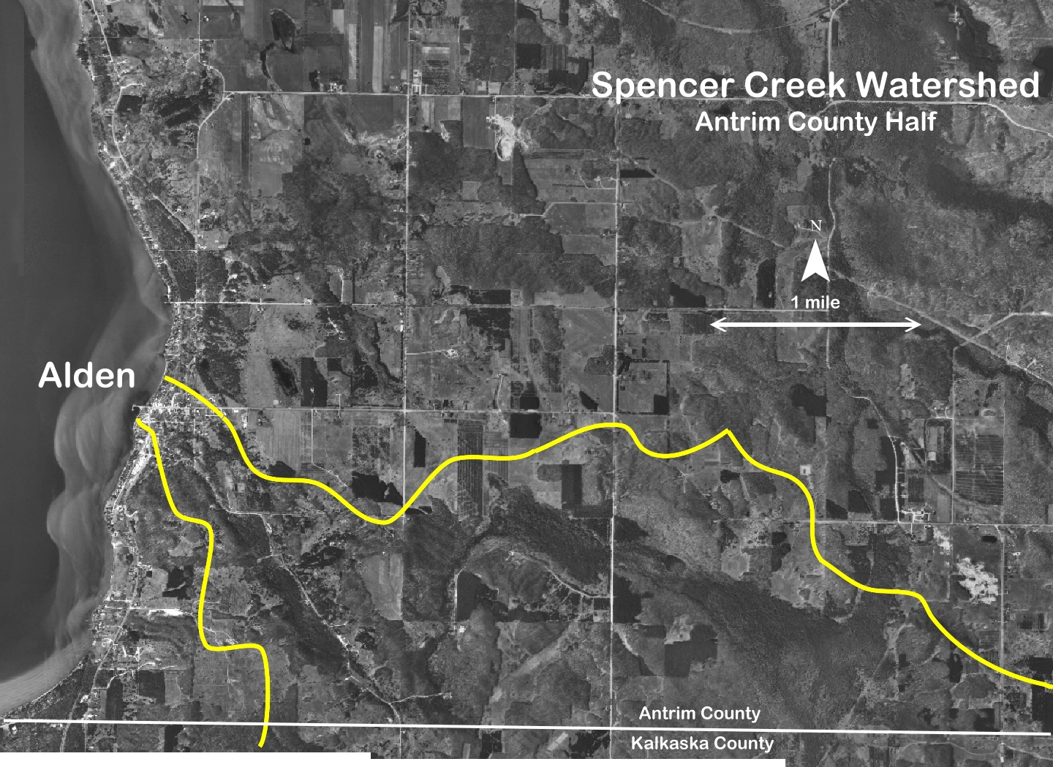

Appendix C
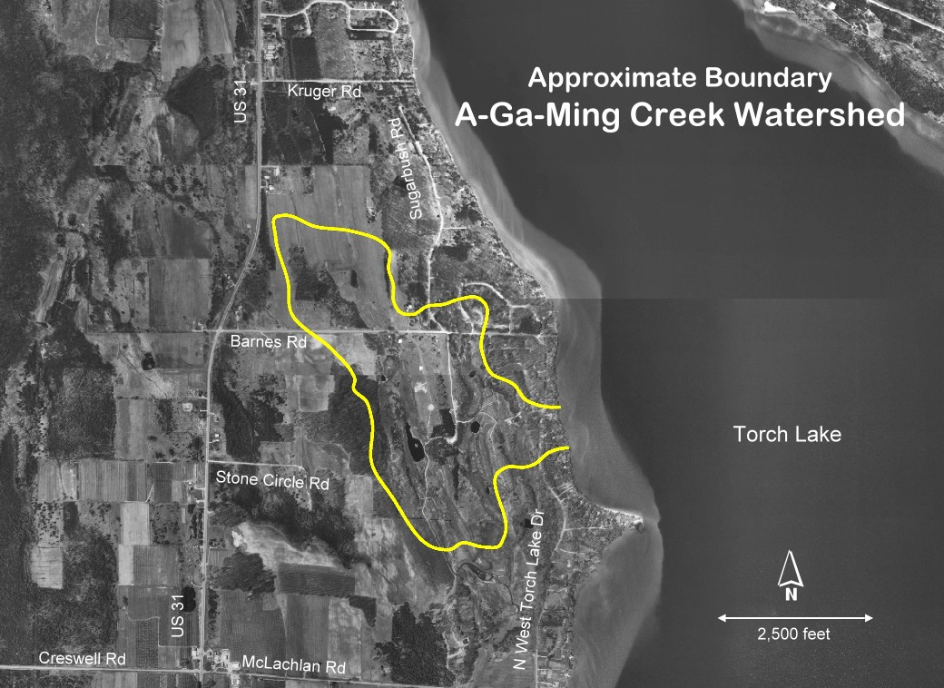
Appendix D
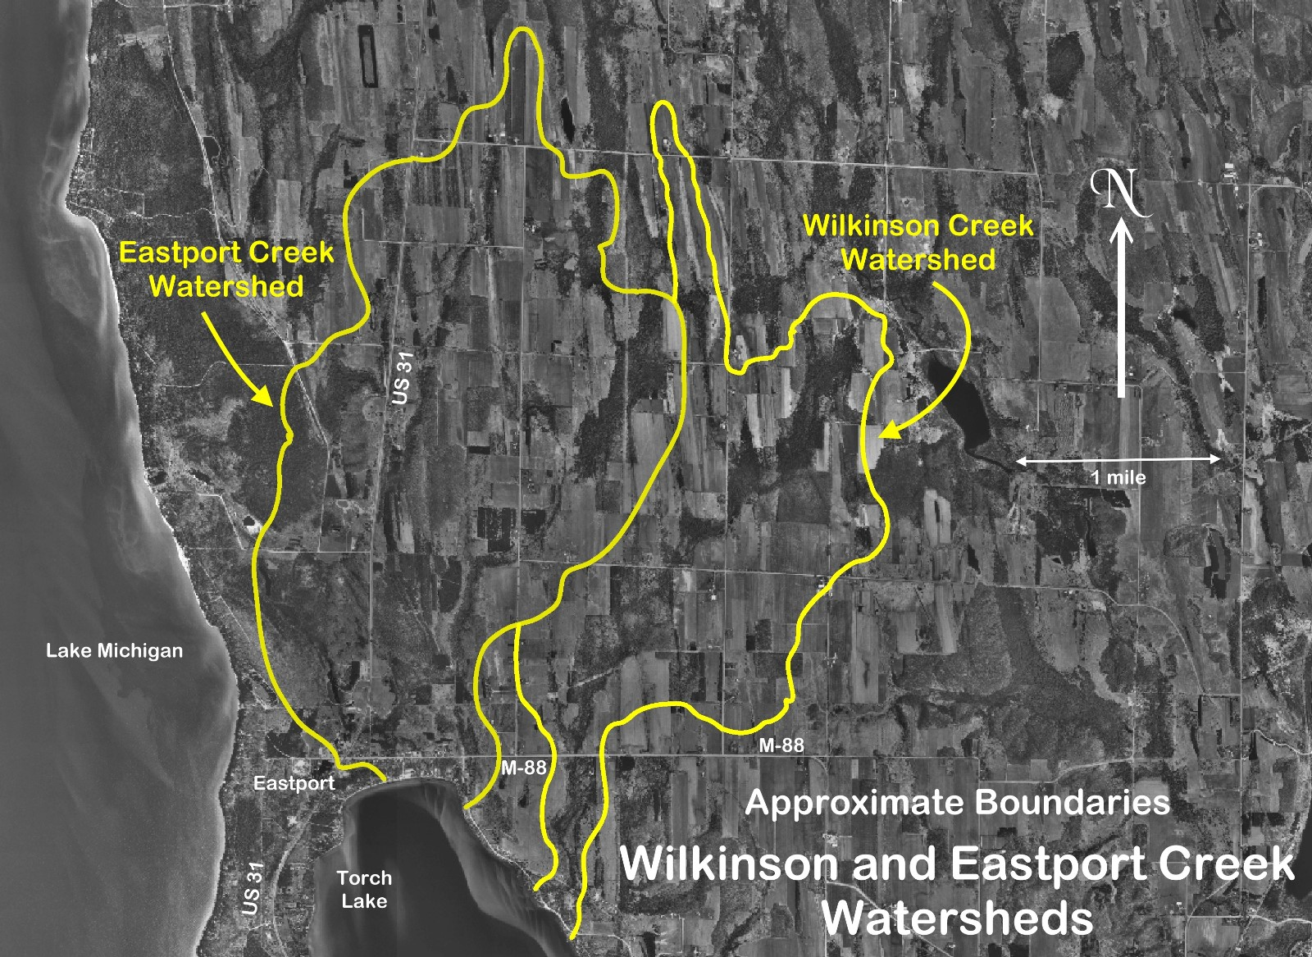

Appendix E
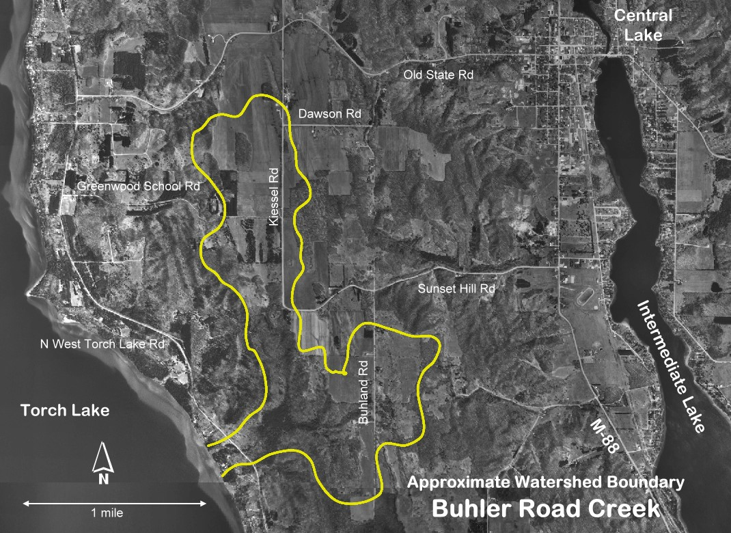

Sources Cited
The ElkRiver/Chain-Of-Lakes Watershed Plan, July, 1989, The Northwest Council on Governments, P.O. Box 506, Traverse City, MI 49685.
Marsh, W.M. and Bornton, T.E., Michigan Inland Lakes and Their Watersheds: An Atlas, Strewart-Jackson Printing Co., Flint, MI, Nov. 1974.
Stone, M., Michigan Maps, Inc., Elk Rapids, MI
Branson, D., Narrative Summary, Oct.. 10, 2004; Jan. 10, 2005, Three Lakes Association, Bellaire, MI, DEQ Water Quality Model for Torch Lake, DEQ Grant # 761P40021.
Three Lakes System Water Quality Model Year 1 Sampling Plan: Torch Lake, Three Lakes Association (Belaire) and Great Lakes Environmental Center (Traverse City), Endicott, S.; DeGraeve, M., June, 2004.
Quality Assurance Project Plan: Development of a Predictive Nutrient-Based Water, Quality Model for the Three Lakes System Year 1 Sampling Plan: Torch Lake, MDEQ contact John Suppnick; prepared for Three Lakes Association, Contacts: Timothy J. Hannert and Dean Branson; Great Lakes Environmental Center Contacts: Mick DeGraeve and Doug Endicott, Sept. 23, 2004.

Michigan Economics Corporation <www.medc.michigan.org/> Michigan Economic z Development Corporation, 300 N. Washington Sq., Lansing, MI 48913, Nov, 16, d 2004.

Acknowledgements
Special thanks are due to Dean Branson and Norton Bretz, without whom this project would have been nearly impossible to complete. Howard Yamagouchi provided excellent visuals of the micro-watersheds in the appendices. Technical equipment training was provided in part by Tim Hannert, and Tina Fields collated much of the data that we gathered on the water. Data analysis was handled by Doug Endicott and the Great Lakes Environmental Center. Most of all we would like to thank the Three Lakes Association for providing us, and all of the other volunteers in the community, with an opportunity to help keep Northern Michigan beautiful.

