Seasonal Variations of Temperature, Dissolved Oxygen, pH, and Specific Conductivity in Torch Lake
Plus Finch Creek Watershed Maps

2005 Summer Internship Report

By

Lauren Elbert and Samantha Fox

Elk Rapids High School

and
Three Lakes Association Interns

MDEQ Grant Number 761P40021

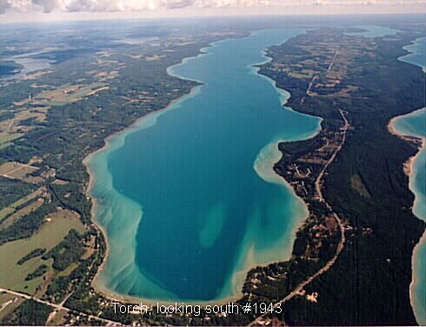
Abstract
As part of a project to build a predictive water quality model for Torch Lake, Three Lakes Association (TLA) volunteers and high school summer interns, measured dissolved oxygen, pH, temperature, and specific conductivity at 15 depths of Torch Lake’s north and south deep basins each month from August 2004 to September 2005. These measurements were made with the aid of sensors and a data logger in a Hydrolab Quanta. The seasonal variation of these measured values will used as part of a new predictive model (Lake 2K), a mathematical simulation of the phosphorus levels in Torch Lake. Oxygen concentrations ranged from about 8 mg/L (ppm) to 16 ppm in the top 5 meters of the north deep basin and from 10 mg/L to 14 ppm in the top 5.5 meters of the south deep basin. There was no evidence of anaerobic conditions near the bottom of the lake at either the north or south deep basin where the seasonal variation ranged from 8 to 10 ppm through the year, which provides evidence that sediment-bound phosphorus is not released from the sediment into the water column through an anoxic process. Temperature proved to be rather predictable. During the summer months, the surface water was warmer and colder during the winter months. Below the thermocline, the water was consistently cold, due to the lack of sun’s warmth. The pH also is consistent near the bottom. However, in the thermocline, it changes with the number of CO₂ consuming plankton. CO₂, when dissolved in water, creates carbonic acid, H₂CO₃. Therefore, when it is taken out, it is more basic, yielding the higher pH levels in the summer months when plankton numbers are at their highest. Lastly, specific conductivity, also the measure of impurities, was generally the same throughout. This shows that Torch is well mixed and clean from top to bottom.
Finally, there is a section on the Finch Creek watershed showing its extent and land use.
Introduction
Torch Lake is a deep, cold, clean glacial lake. While other lakes in the area are losing their pristine nature and falling into pollution, Torch Lake has remained clean. The Three Lakes Association is investigating the reasons why Torch Lake remains pristine. If the reason is discovered, this knowledge may permit other lake associations to learn from Torch Lake so their lake too can remain uncontaminated.

On June 1, 2004, Three Lakes Association was awarded an 18-month grant from the Michigan Department of Environmental Quality to build a predictive water quality model for Torch Lake. The goal of this project was to develop a mathematical simulation (model) of Torch Lake that could be used by decision makers as a management-of-change tool. These decision makers include township trustees/planners and designers of future economic development projects in the Torch Lake watershed. Appropriate use of this tool may help protect the future quality of water in Torch Lake.

During the summer of 2004, TLA’s volunteers and summer interns began recording dissolved oxygen levels, pH, specific conductivity, and temperature at the two deepest points in North and South Torch. The results of the study were compiled into several graphs, and from those graphs, conclusions were made about why each of the parameters varies at a specific depth or time of the year. After a year of studying the lake, graphs have been made and interpreted to help explain the seasonal changes in Torch Lake from 2004-2005.

Methodology
The instrument used to measure four water quality parameters in Torch Lake is called a Hydrolab Quanta, manufactured by Hach Inc. A Hydrolab can be used for profiling water quality parameters in lakes at certain locations and depths. The parameters measured using the Hydrolab are temperature, pH, specific conductivity, and dissolved oxygen. The Hydrolab contains a small propeller used to circulate water through the device. The data collected is then sent to a handheld receiving apparatus, which records the information. This can be connected to a computer in order to manipulate the data into graphs.
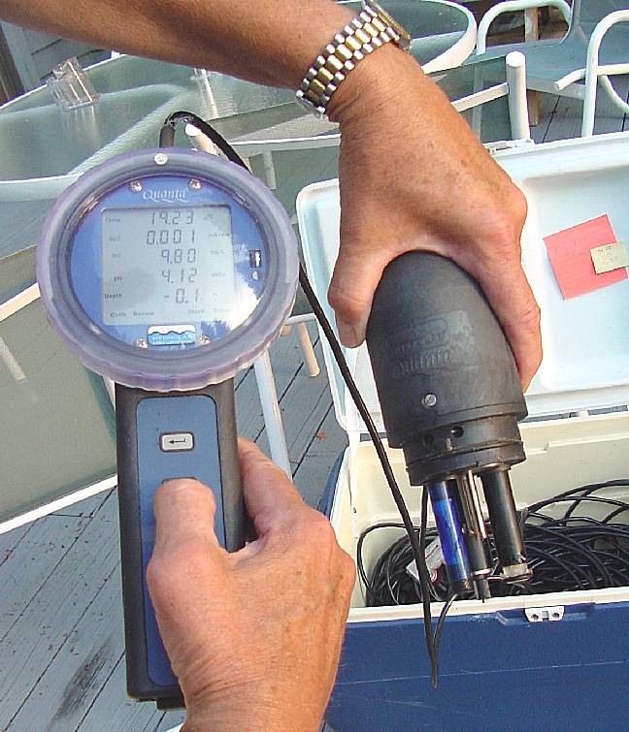\
Hydrolab with receiving apparatus

Temperature variations were easy to interpret, the colder winter months yielded colder water, especially at the shallow depths, less than 5 meters. The study also looked for the depth at which the temperature dropped more rapidly, i.e. thermocline.

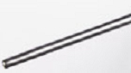
Hydrolab temperature sensor

The temperature is measured with a 30 K ohm variable resistance thermometer. Temperature is critical for interpreting other data collected.

Determining how acidic or how basic the water is based on concentration of hydrogen ions in a given liquid and is measured as pH, which can range from very acidic (pH 1) to very basic (pH 14). Higher or lower values relative to neutral pH (pH 7) can help determine the bioavailability of nutrients.

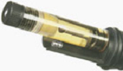
Hyrdrolab pH sensor
The pH sensor is a glass bulb with an electrode-detecting device. The glass is impregnated with potassium chloride (KCl) and can only be permeated by hydrogen ions. There is a liquid filled tube in the middle with 3M KCl, and a salt bridge is formed. The bridge allows one to measure the rate of reaction between the KCl and hydrogen ions, which gives the measure of the pH.

Specific conductivity is a measure of ions, e.g. salts, dissolved in water. The more ions in water the more electric current can be conducted. High specific conductivity values mean that more ions are present, such as calcium ions, which is an indicator of water hardness. In many studies, specific conductivity can be used to measure the amount of runoff sediment in tributaries.

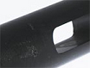
Hydrolab specific conductivity sensor

The specific conductivity sensor contains four graphite electrodes in an open cell design, allowing water to pass between the electrodes. The probe measures the current between two of the electrodes. The other two electrodes are simply used to avoid error.

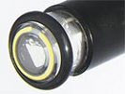
Hydrolab dissolved oxygen sensor

The fourth parameter measured is the amount of dissolved oxygen (DO) in water. All organisms need oxygen, and plants create it. Animals respire CO₂ and plants need CO₂ for photosynthetic means. If there is not enough DO in the water, aquatic life cannot exist, whether it is plants or animals. Plants may be capable of surviving as long as there is dissolved carbon dioxide (CO₂) in the water if there is enough sunlight to support photosynthesis, which produces oxygen. However animals need the oxygen, and if the oxygen level is too low, they will have a harder time living. The dissolved oxygen is measured by an oxidation-reduction reaction. There is a selective membrane allowing only oxygen to permeate it. The current is then measured from the electrochemical reduction of oxygen.

Measurements were made at about 15 depths at two different locations; typically every 3 meters from 0 to 30 meters depth and then every 10 meters to the bottom of the lake, which is about 90 meters in Torch Lake’s south deep basin.
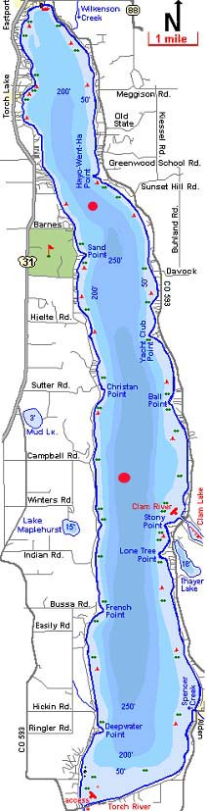
Map of Torch Lake showing north and south basin sampling locations (in red)
The data collected with the Hydrolab was from two different basins of Torch Lake. The two basins were on opposite ends of the lake, one in the North and one in the South. The fieldwork was conducted using a GPS (global positioning system) to be sure the data was collected from the same place every time. The red dots on the map represent approximate locations for the North and South basin. The South basin has a latitude of W44º42.7” and a longitude of N85º18’36.2”. The North basin’s coordinates are W45º2’24.2” and N85º19’25.9”. The north basin is approximately 70 meters deep, and the south basin is approximately 80 meters deep. The study called for monthly measurements in the fall, winter, and spring months, and during the summer the basins were measured every two weeks. The Hydrolab sensor was then lowered in intervals of five meters until the phototropic level was reached. Most changes in the four parameters occurred within thermocline, the area above the phototropic level, so more measurements where needed for a more accurate graph. After reaching the phototropic level, the sensor was lowered in ten-meter segments. This can create accurate, consistent database that can be used to make inferences about other processes in the lake.

Results and Discussion
In the graphs on pages 14-20, one can notice obvious changes in the temperature, dissolved oxygen, pH, and specific conductivity at different depths. Many of these changes occur at the thermocline and phototropic level, between twenty and thirty meters below the surface.

Heat given off from the sun affects the temperature of the water. Therefore, in the warmer summer months, the water will be warmer, while in the colder winter months the water is cooler. However, since Torch is such a deep lake, the sun’s light cannot penetrate all the way to the bottom, only warming the top 5-10 m. At the phototropic level, the temperature drops and becomes consistently cold at the bottom. The graphs show that from month to month, the bottom temperature is always between 2°C and 7°C. In the late fall, the surface water is cooled by the colder air, and by convection the now dense surface water travels down until it reaches colder more dense water and it can go no further. This is called the fall mixing and only happens above the thermocline. However, the colder water being denser water does not always hold true. Around 5ºC, the density decreases as the water gets colder until it becomes ice, which is less dense than water. The graph always shows the least dense water above the more dense water. In the summer, the warmer water is at the top, and the colder water, still above 5ºC, is at the bottom. The winter months have 0ºC water at the top and 3ºC water at the bottom, holding true to the rule for water under 5ºC.

Similarly to the temperature of the lake, the pH is also affected by the season. In the summer months, plankton is more active in Torch’s waters. The plankton consumes CO₂ which makes the water less acidic in the summer. This is because of a chemical reaction that occurs between CO₂ and H₂O, which yields hydrogen ions (H⁺) and carbonate ions (CO₃⁻²). In the winter months, however, there is less plankton activity, meaning more CO₂ and a lower pH. Additionally, all forms of precipitation are more acidic than the water of Torch Lake. This means that during the spring when the snow is melting and there is more rain, there will be a decrease in the pH making the lakes pH more acidic.

The specific conductivity of Torch Lake has very little variation with season or depth. Because Torch is such a deep, clean lake, there is very little electric conduction in its waters. One can notice a small jump in the specific conductivity towards the bottom, as the sediments in the depths of the lake are more conductive than the shallower waters. The volume of the lake is so large, that from month to month, a great amount of contaminates would have to enter the lake in order to change the specific conductivity. The small variation in the specific conductivity means that the impurities causing the electrical conduction do not vary throughout the lake. This is consistent with measurements of phosphorus which do not contribute much to the conductivity but which are known to have a relatively small variation with season and depth as well.

The graphs below shows twelve months of data for temperature and dissolved oxygen at depths between two and five meters. The numbers along the x-axis represent monthly measurements. In the summer months there is a lower concentration of dissolved oxygen, because colder liquid is capable of dissolving more gas than warmer. Additionally, there is more plankton activity near the surface, which consumes oxygen. Once below the thermocline, there is less variation in the dissolved oxygen levels due to consistently cold temperatures.

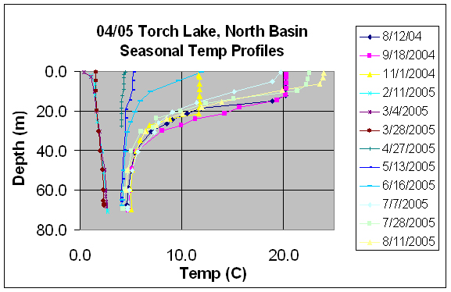
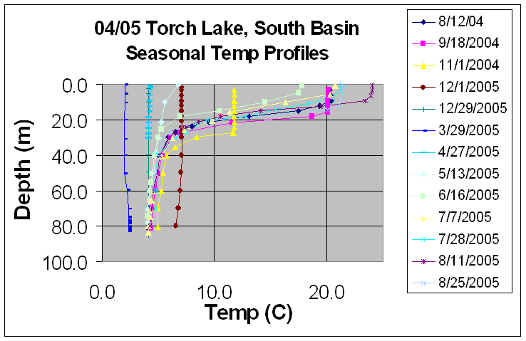
Seasonal temperature profiles from 2004/5 for the north and south Torch Lake basins
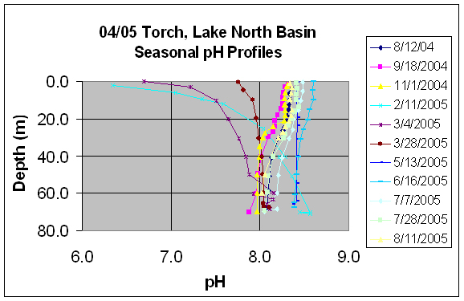
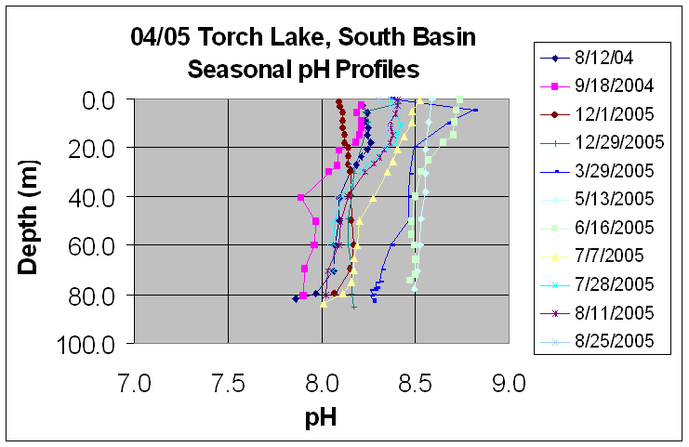
Seasonal pH profiles from 2004/5 for the north and south Torch Lake basins
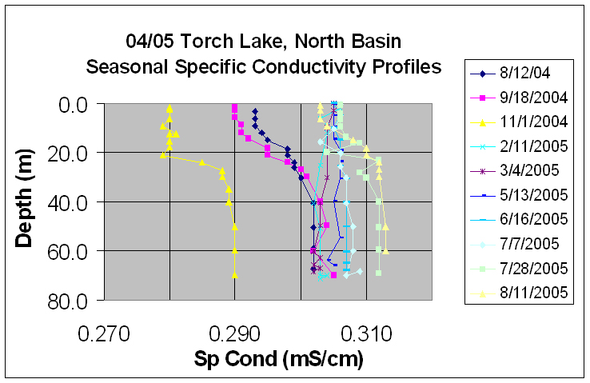
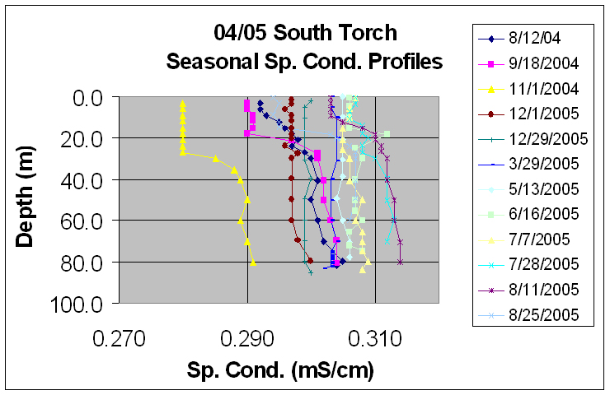
Seasonal specific conductivity profiles from 2004/5 for the north and south Torch Lake basins

Dissolved oxygen seasonal changes in north basin at 2m and 5m depths

Dissolved oxygen seasonal changes in south basin at 2m and 5m depths
Most months show a jump in dissolved oxygen levels at the phototropic level, about twenty meters below the surface. This is due to an abundance of algae that come up from the depths to conduct photosynthesis, releasing oxygen as a byproduct. Again, in the deeper water where it is colder, the water can hold more oxygen. The odd drops on May and July in the North basin can be attributed to hitting the bottom of the lake and recording incorrect data due to the sediments. Other strange jumps, such as some found in the South basin graph are considered to be a malfunction in the machinery.

Near the bottom of Torch, at both the North and South basins, the dissolved oxygen levels are higher. The following graph shows the levels of dissolved oxygen at seventy to seventy-five meters depth at each basin.

The study proved that the four parameters were easy to measure and graphs could be created. Changes due to depth or season could be explained after some research on the properties of the water and each of the measured quantities. These changes may show what parameters affect or are affected by phosphorus levels in the lake. Generally, dissolve oxygen plays a large role in phosphorus levels in the lake. If the DO levels drop below 2 mg/l near the bottom of the lake, it has been shown by other studies that phosphorus is more likely to dissolve. Since the DO levels in Torch are always greater than 2 mg/l in this study, it can be concluded that this problem will not be one that affects this lake. However, in a shallow lake, there is typically a season were decaying organisms at the bottom of the lake consume large amount of oxygen, occasionally making the levels drop below 2 mg/l, causing more phosphorus to dissolve. From the results of this study, one can see that Torch is fairly regular. Large lakes, such as Torch, require huge changes to have a small effect on the lake. Being such a large lake, the values of dissolved oxygen, temperature, pH and specific conductivity can be predicted to have a small change above the thermocline, and be fairly constant below. The report will hopefully contribute to future studies on Torch Lake, and other deep cold lakes similar to Torch.

Seasonal changes in the dissolved oxygen in the north and south basins of
Torch Lake at depths of 70-75 m
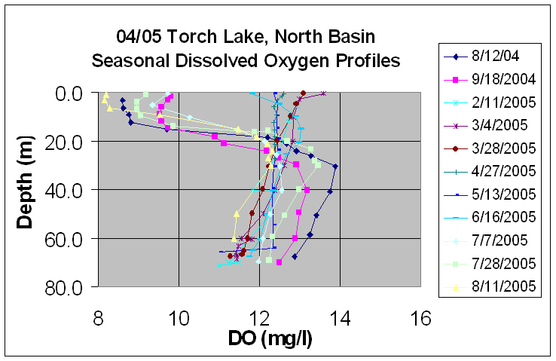
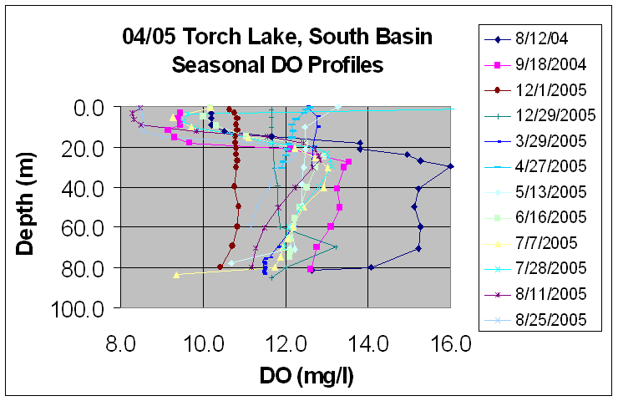
Seasonal dissolved oxygen profiles from 2004/5 for the north and south Torch Lake basins

Acknowledgements
The Three Lakes Association provided a great opportunity for us as well as other students in the area to learn more about our local environment. We could not have done it with out the help of Dean Branson and Norton Bretz. With their individual expertise in science, they provided us with a clearer understanding of Torch Lake, Clam Lake, and Lake Bellaire as well as surrounding streams and watersheds. They took time out of their schedules for our weekly field work days, and were immensely helpful throughout the essay writing process.

Additionally, we would like to thank Howard Yamaguchi. He provided us with the knowledge and equipment necessary to learn more about local watersheds, and created the maps and graphs found in Appendices A-D.

Finally, we would like to thank the rest of our team. This includes the other interns, and the volunteers that were at our meetings every Thursday. Having more people allowed us to accomplish more this summer than we otherwise could have.

We can only hope this program continues in the future so that other students can gain as much knowledge and hands-on experience as we did. It has truly broadened our perspectives, and shown us the importance of environmental science.

Bibliography
Three Lakes Association (TLA), PO Box 689, Bellaire, MI 49615
Great Lakes Environmental Center, 739 Hastings St., Traverse City, MI 49686
Development of a Predictive Nutrient-Based Water Quality Model for the Three Lakes System Year 1: Torch Lake, T. Hannert, D. Branson, M. DeGraeve and D. Endicott, Three Lakes Association and Great Lakes Environmental Center, 04 MDEQ grant PO# 761P40021 (June, 2004).
The Elk River/Chain-Of-Lakes Watershed Master Plan, July, 1989 by the Northwest Council of Governments, PO Box 506, Traverse City, MI 49685.
Callinan, Clifford W., P.E. New York State Department of Environmental Conservation. “Water Quality Study of the Finger Lakes”. PDF. Updated July 2001. <http://www.dec.state.ny.us/website/dow/fingerlakes/synopticwq.pdf>.
Hach Environmental. “Hydrolab Quanta.” <http://www.hydrolab.com/products/quanta.asp>.
Lake Singletary Watershed Association. <http://www.lakesingletary.org/watertesting.htm#Top>.
Meehan, Holly. State University of New York. “Water quality monitoring of five major tributaries in the Otsego Lake watershed, summer 2002.”
Michaud, Joy P. Access Washington. “pH: Why it is Important?” Updated 26 May 2005 <http://www.ecy.wa.gov/programs/wq/plants/management/joysmanual/ph.html>.
Our Lake. “Specific Conductivity.” Updated 15 June 2005. <http://www.ourlake.org/html/specific_conductivity.html>.
Water on the Web. “Dissolved Oxygen: Why is it Important?” Updated 11 May 2004. <http://waterontheweb.org/under/waterquality/oxygen.html>.

Appendix A

Finch Creek Watershed
Appendix A consist of pictures, graphs and information relating to the Finch Creek watershed. Finch Creek flows into Clam Lake, which then flows into the southern end of Torch. The watershed for Finch Creek covers about 7.2 square miles, a large majority of which is forest land (about 65%). The next largest land use is about 19.5% grass and shrub land. There are lower percentages of agricultural field (11.6%), urban building areas (2.9%), and wetlands (1%). Actual acreage for these land uses can be found in Appendix C. This information is important because it can determine what effects human activities or lack thereof have on the water quality of the creek due to its watershed.

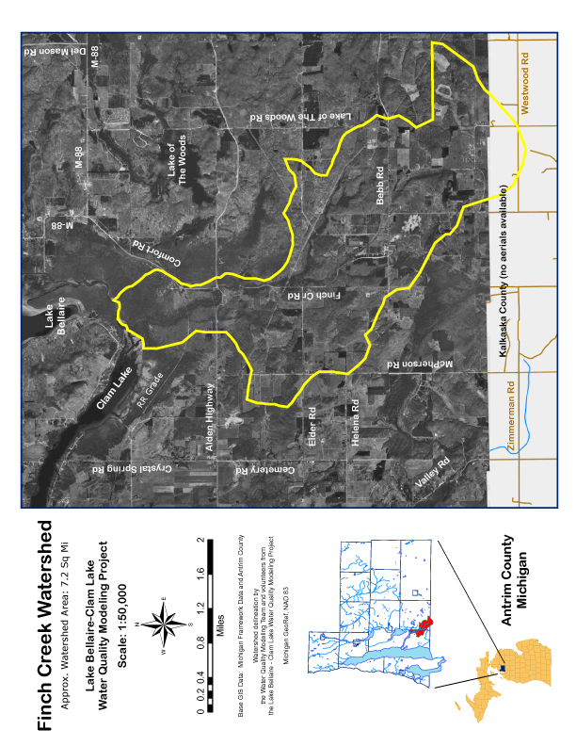

Aerial photo of the Finch Creek watershed
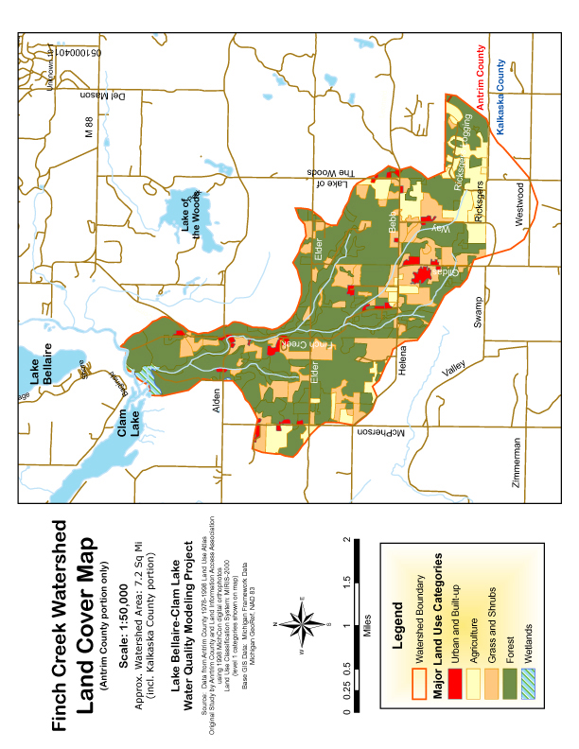

Land-use Categories in the Finch Creek watershed,

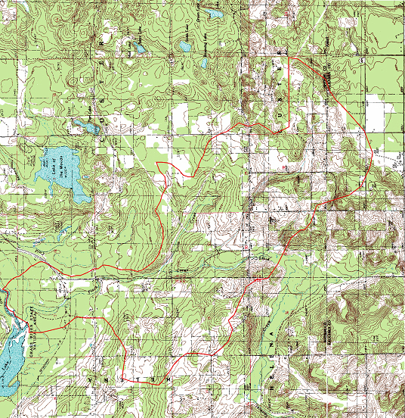

Topographic map of Finch Creek watershed
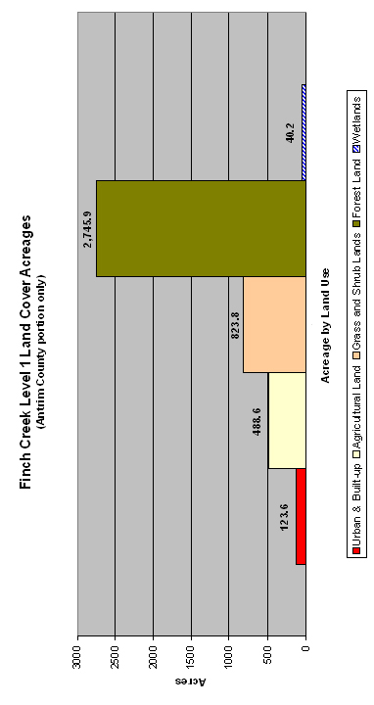

Percentage of land-use by category in the Finch Creek watershed

